Global Symbols Board Builder Instructions
https://app.globalsymbols.com/
Welcome to Board Builder, a chart builder for Augmentative and Alternative Communication (AAC) users and anyone wishing to introduce images, pictographic and other types of symbols as a way of communicating information, messages and requests.
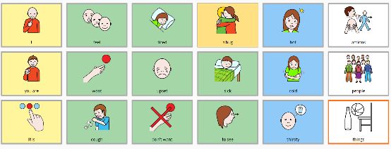
Board Builder links to the multilingual Global Symbols repository, Open Symbols and The Noun Project to provide a range of symbol sets as well as uploaded personal images that can be used in any position on the grid with various background colours or borders. Text labels are used below or above the symbols and cells can be linked to other boards to create a board set.

Board Builder invites you to ‘sign in’ with Global Symbols
If you have not already registered on the Global Symbols site to download symbols, when you launch Board Builder you will need to create an account in order to save all your charts.
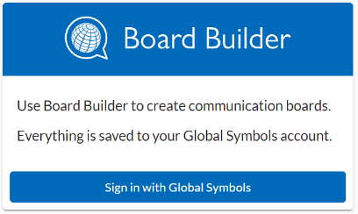
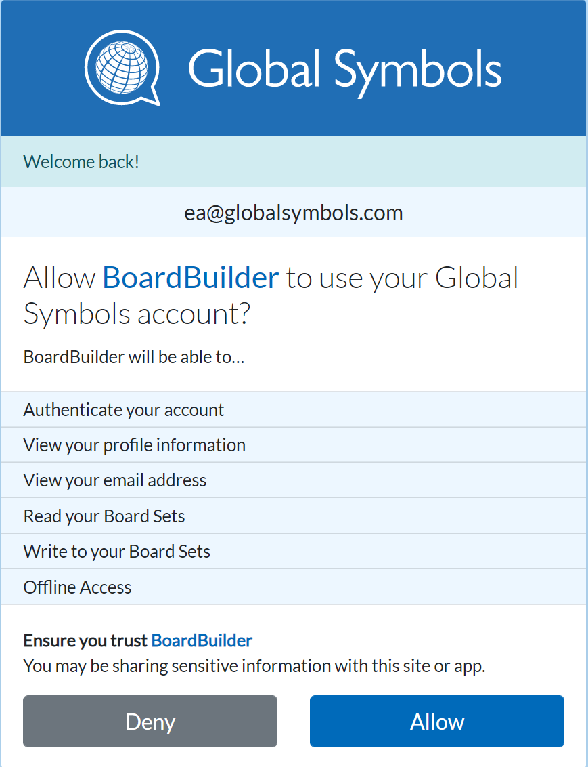
Once you have the Global Symbols account you will be asked to allow or deny Board Builder access, once you are happy with the way the system works.
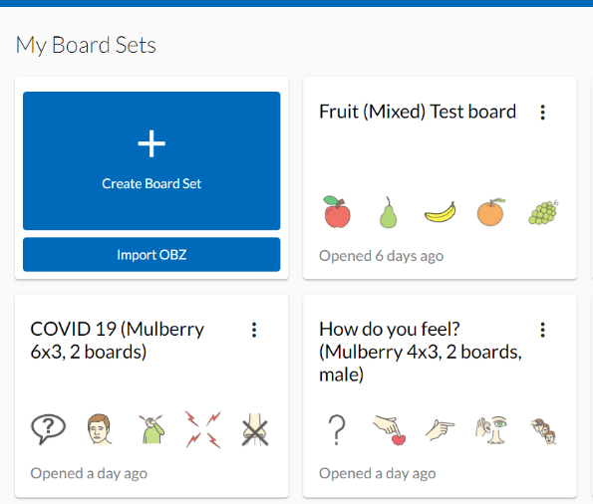
You can select the Create Board Set button to add a board to the edit area or import an .obz file. This is a collection of boards with linking cells or folders you may have made on another application such as CBoard or CoughDrop. Board Builder uses the freely available .obz and .obf open file formats and the uploaded file will appear under ‘My Board Sets’, where it can be edited. You can always reach your board set from your profile menu.

Featured Board Sets
available on https://globalsymbols.com/about/featured-board-sets
These are boards and information sheets that have been made public once they have been created by the author. They can be opened in ‘read only mode’ once you have registered on the site, by selecting title of the board. Once opened select the ‘pencil icon’, you can then make a copy and edit the content. Where user images have been uploaded, (rather than symbols from the various symbol sets) these will disappear if the original owner no longer wishes to share them.
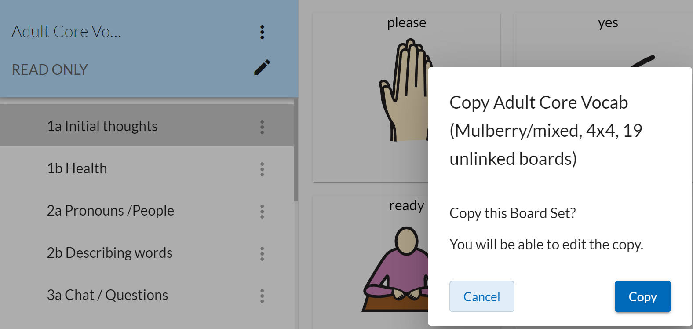

Create a Board Set
Select the ‘Create Board Set’ button and a ‘pop up window’ appears ready for you to add the Board Set title, that can be changed at any time. The properties for the first board are chosen at the next stage.
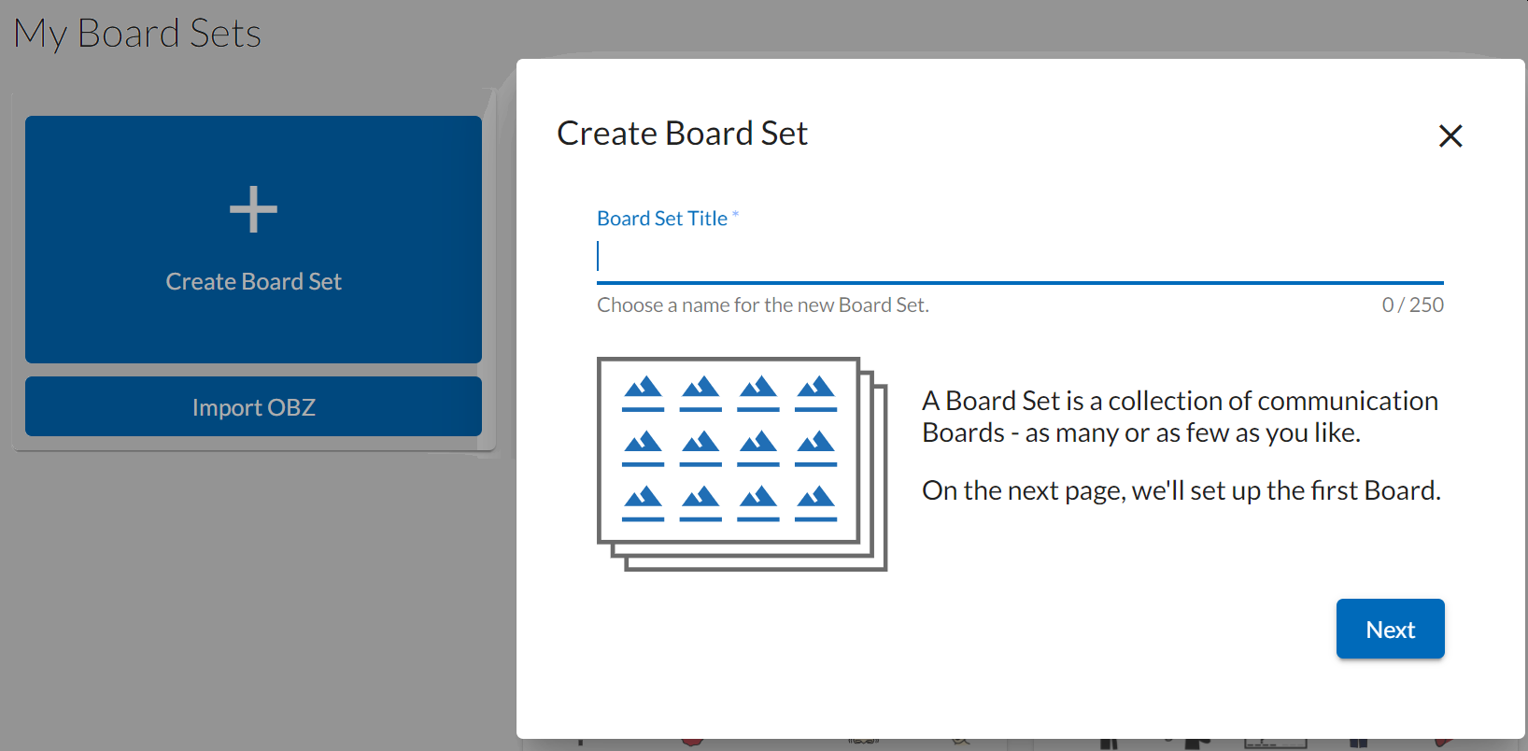
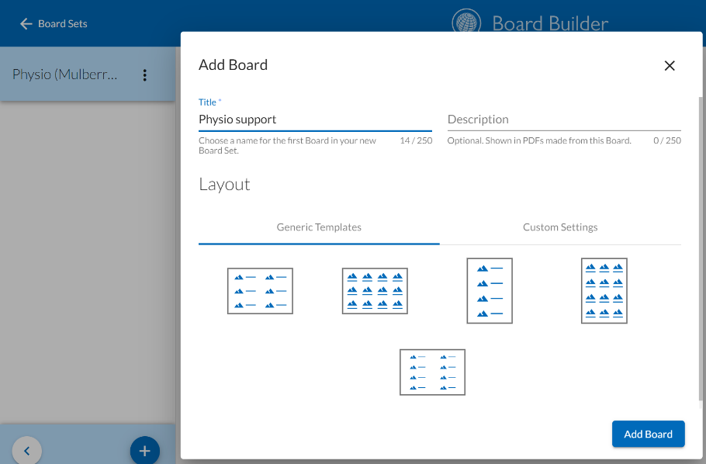
First Board
- Add a title and a description if required. Choose a layout from the Generic Templates (select one of the images) or select Custom Settings.
- Use the slider to add or subtract rows or columns watching the change in number. These choices can be altered at any time. Select ‘Add Board’.
Something to think about… 4 columns across and 3 rows down allows for easy to select sized cells and works well on a tablet in landscape mode and for an A4 printed PDF.

Adding and editing boards
- Select the plus sign at the bottom of the left hand edit area to create more boards.
- Each new board comes with similar properties as the first board. There is still the ability to choose to have a text label above or below a symbol or to have it hidden when you select a custom view. Even if you choose to hide the label text to speech can be used to read it aloud if you want to use the board in an app.

Edit Cells
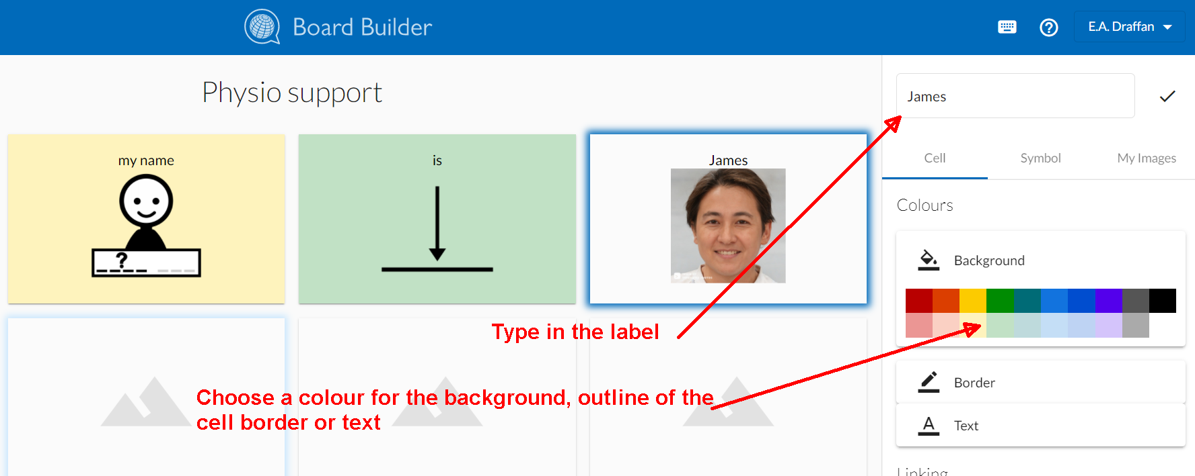
Select a cell and a set of controls will appear on the right. Fill the top edit box with the symbol label.
- For that one cell you will see the range of colours available for the cell background, border and text.
- At this stage it is possible to link the cell to another board if one is already available and a list of board titles will appear (Use the + sign at the bottom of the left-hand menu and add a title to the new board).
- A little link icon will appear on the linked cell when a board has been chosen. Its position on the left-hand menu list will become indented.
- You can also clear your edit choices. If you are happy with the look of the cell – keep it highlighted.
- To move cells with their contents, use the move earlier or move later buttons – these work with the tab and enter keys as well as the mouse. You can move cells along the rows and they will drop onto the next row or go back up a row depending on the direction of travel.
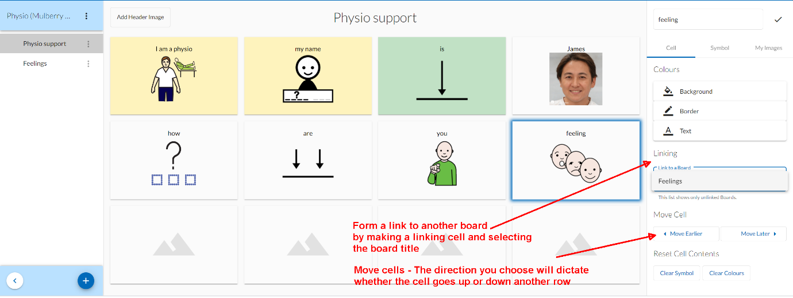

Add Symbols and Images

- Select Symbol to choose the symbol repository and add a search word – this may not be the same as the label. For example, if there is no symbol for ‘I’ you may wish to try ‘me’ if you are using the English language, in order to find the right symbol. If you choose to use the Global Symbols repository, you will have a choice of symbols sets and languages.
- If you do not see your language, you can still use the symbols, but you will need to search in English for the translated match to your label.

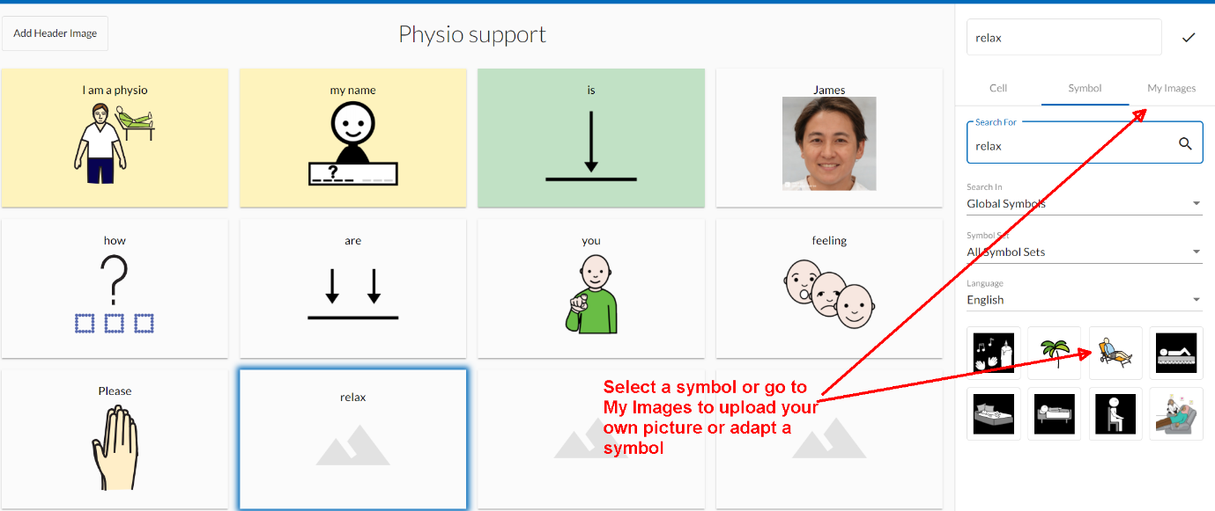
- Add your own images by using the next tab, where you will find an image upload area. Here you will always see the images you have saved – you have 10MB of space so you may want to delete those you do not use by going to your profile and selecting ‘Symbols’.

- When you select a symbol, you will find Symbol Creator allows you to adapt open licenced symbols and your own images.

- You can add shapes, lines and arrows etc. plus text in styles, size and colours of your choice. This means that a symbol or group of symbols can have additional elements that can change the tense, number or category.

- When you download your image, it can be saved as a .png or .svg

- If you view your symbols from your profile and do not open Symbol Creator you can still save to a device as a .svg, edit or delete your own symbols by selecting the three vertical dots beneath each image.

Don’t forget that symbol labels can be added separately in Board Builder. This keeps them independent of the image, so they can be changed and read aloud with text to speech apps.

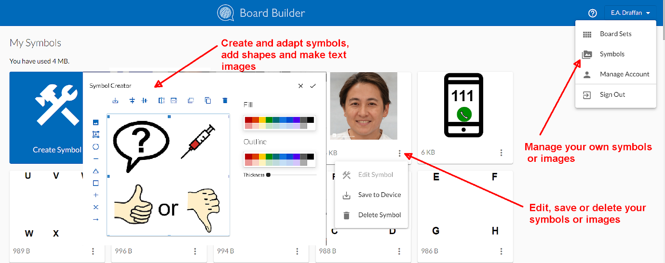

- As you build boards you may need to move between cells or refresh the browser page to check the board is saved to your Global Symbols account.

Exporting Boards
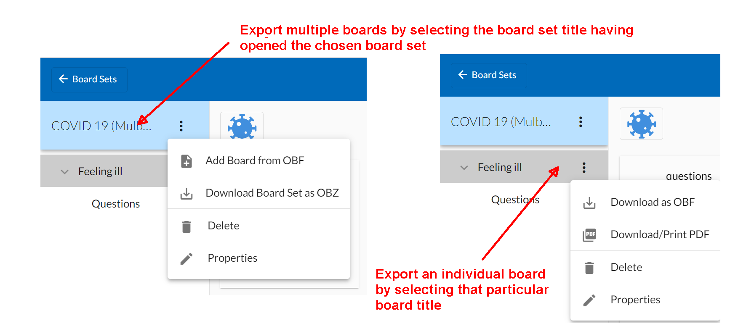
- Each board has a set of properties that allow you to download your board in .obf format or print as .pdf. The board can be used with an app such as CoughDrop or Cboard that accept .obf and multiple boards as .obz open board formats.

- Make sure each board has the correct display orientation and font size when printing as .pdf. Font sizes may need to be lowered to make them all the same size in each cell. Too many cells across or down for the paper size or the use of phrases may also mean text labels have to have smaller fonts.
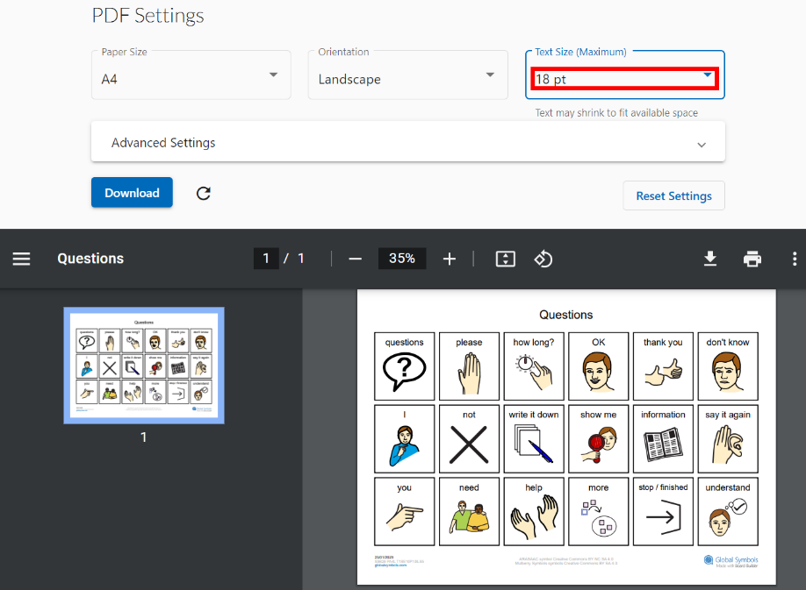
- Delete a single board using the bin found on the same export menu.

- Use the top left link to return to the Board Sets area where you will find all your boards. If you want to change the name of a board, open the board set and use the pencil to change the properties.

- At this stage you can add an external .obf file formatted board, download a board set as an .obz file, delete the entire board set and via the properties’ menu, make your board set private or public.

