Global Symbols

AAC Symbol User Voting Sessions
These voting sessions usually take place on a one to one basis with a therapist, assistant, family member or carer working with the AAC user.

Materials Required:
- Video/Stills Camera.
- Consent forms for participants if you are using the results for research purposes or the anonymised data collected will be open to the public.
- PC/Tablet running a grid style AAC app that allows for image uploads (ideally, the client’s own AAC device) with programmable cells.
- Pre-made voting grids loaded with as many new symbols as are felt suitable for a session without causing fatigue and designed to suit user skills. The system must also be setup/adapted to work with the individual’s access method/device.
AAC User with eye tracking and Smartbox Grid 2 software set up with symbol voting.
- The installed or imported voting files (grids) need to have the equivalent of ‘Yes’, ‘No’ and sometimes ‘Maybe’ for example thumbs up and down or thumbs up, intermediate thumbs across and thumbs down in a suitable size with the chosen new symbol in the central position.
- User settings must ensure that the controls for the cell highlighter (whether scanning using switches or dwell select for touch, headtrackers, eyegaze etc) clearly indicate to the camera that a specific voting selection has been made.
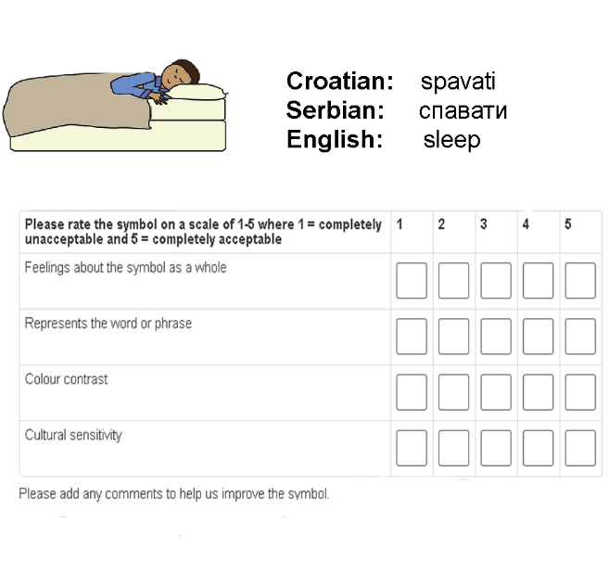
- A paper based scoring sheet can be used with results manually uploaded to the online voting system depending on comments where thumbs down represents ‘1’ and thumbs up represents ‘5’ if very positive and the scale numbers in between where alternative comments are elicited from gestures etc. It is important to note all the other comments and show of emotions about each symbol.

Set up:
- Explain the project background, purpose of the voting session and introduce the symbol voting interface to both the participant and carers.
- Explain consent related issues (i.e. is the family/individual happy for video/audio to be used for recording, research and/or dissemination purposes).
- Sign consent form.
- Set up camera as appropriate (if participant does not wish to have their face portrayed on film, then position camera over shoulder, so that only the voting screen is clearly visible and user is not recognisable).
- Establish definite “Yes”/”No” communication gestures and “maybe” if using three symbols.

Voting:
- Explain the key features of the symbol voting grid, making sure the reasons for voting in favour or against a particular symbol are clear e.g.
  - feelings about the symbol as a whole (immediate reaction, iconicity, transparency, ease of recognition)
  - represents the word or phrase (referent/concept)
  - colour contrast (outline and colours used for clarity and visually impaired)
  - cultural sensitivity (appropriate and relevant) and
  - general comments not mentioned in the list above, such as size or background etc.
- As the first Symbol appears, state the intended meaning of the symbol to the participant and ask how well this symbol represents the concept, indicated by choosing the three (or five) voting options on the bottom of the screen.
- Once a choice is made, confirm with the “yes/no” gestures established earlier.
- Note the choice on the scoring sheet.
- With the vote choice established, ask the reason for their choice by indicating one (or more) of the stated reasons.
- Once a choice is made, confirm with the “yes/no” gesture established earlier.
- Note the choice on the scoring sheet.
- Continue to the next symbol vote by choosing the arrow pointing right at the top right corner of the grid.
- Repeat steps 2 to 8 (it may take two or three votes to establish clarity).

