Global Symbols

AAC Symbol Forum Voting Sessions
These voting sessions usually take place with groups of therapists, specialist teachers, others working with AAC users (the AAC Forum) and on occasions the graphic designer. The graphic designer and core team will have worked on the initial design and early acceptance of the new symbols prior to the workshop. This can happen remotely by using the voting system independently of the AAC Forum.

Materials Required:
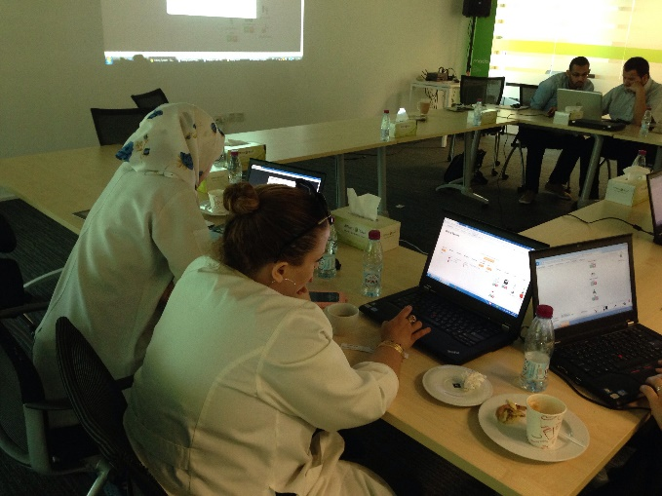
- Presentation slides with a projector and/or computer link up
- Batch of symbols that have been uploaded to the symbol voting system (web link) or available on the presentation slides.
- User laptops/tablets with access to the internet and the voting system or paper based score sheets.
- Workshop attendance sheet to confirm emails and signatures if required.
- Consent forms if you want to use photographs/video/audio to disseminate the work.

Set up:
- Explain the project background, purpose of the voting session and introduce the symbol voting interface to participants
- Explain consent related issues for those present and when visiting AAC users who will be voting (i.e. is the family/individual happy for video/audio to be used for recording, research and/or dissemination purposes).
- Meanwhile attendance and/or consent forms are passed around where required.
- Set up camera or audio as appropriate (if participants do not wish to have their faces portrayed on film, then position camera over shoulder, so that only the voting screen is clearly visible and the user is not recognisable).
- Establish a protocol for making comments about the symbols as they are shown. Make sure everyone is involved where possible.

Voting:
- Explain the key features of the symbol voting grid, making sure the reasons for voting in favour or against a particular symbol are clear and the Likert scale is understood e.g.
  - feelings about the symbol as a whole (immediate reaction, iconicity, transparency, ease of recognition)
  - represents the word or phrase (referent/concept)
  - colour contrast (outline and colours used for clarity and visually impaired)
  - cultural sensitivity (not liable to offend, appropriate and relevant) and
  - general comments not mentioned in the list above, such as size or background etc.
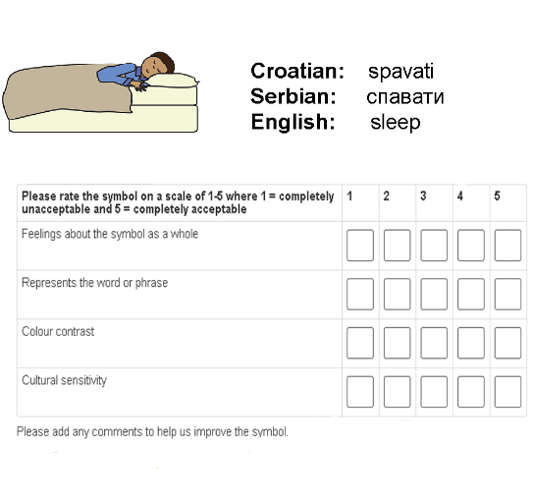
- As the first Symbol appears, state the intended meaning of the symbol to the participants and ask how well this symbol represents the concept, indicated by choosing five voting options (1-5).
- Once a choice is made, confirm comments have been added to the free text area, then select submit.
- Continue to the next symbol
- Repeat the steps until all the symbols in the batch have been voted on (it may take two or three votes to establish clarity).

After the workshop
- Gather results from online voting / upload paper based results
- All symbols that receive 3.5 on average or below will probably need redesigning based on the comments received
- Report back to participants with a summary of the results
- Keep participants in touch with the work and plan follow up batches for the next set of new symbols and those that need redesigning.
- Up to around 60 symbols can be voted on during a two hour face to face workshop once participants have become used to the system. It is also possible to set up remote session so that participants can carry out the voting in their own time.

