Global Symbols

Online Voting System
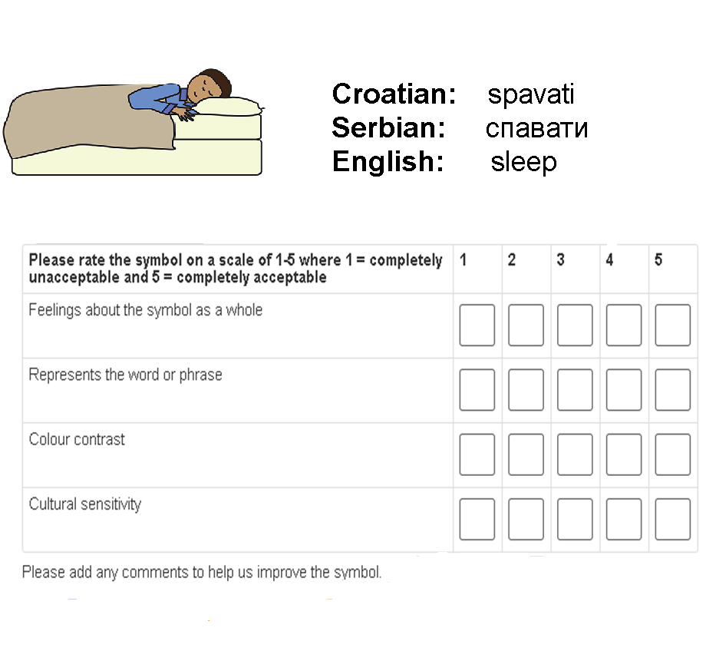
Global Symbols has a collection of Symbol Sets and the voting system is designed to allow owners of these sets to check whether users are happy with their symbol designs. The symbols have multilingual labels built around a concept linking classification process.
The voting system is based on newly created draft symbol sets as a series of surveys, where voters can decide whether symbols are acceptable. Participants are asked to look at each symbol and select a checkbox based on a 1-5 scale, where 1 is 'completely unacceptable' and 5 is 'completely acceptable'.. The criteria are:
- feelings about the symbol as a whole (immediate reaction, iconicity, transparency, ease of recognition)
- represents the word or phrase (referent/concept)
- colour contrast (outline and colours used for clarity and visually impaired)
- cultural sensitivity (not liable to offend, appropriate and relevant)
Followed by a general comment on ideas not mentioned in the list above, such as size or background etc.
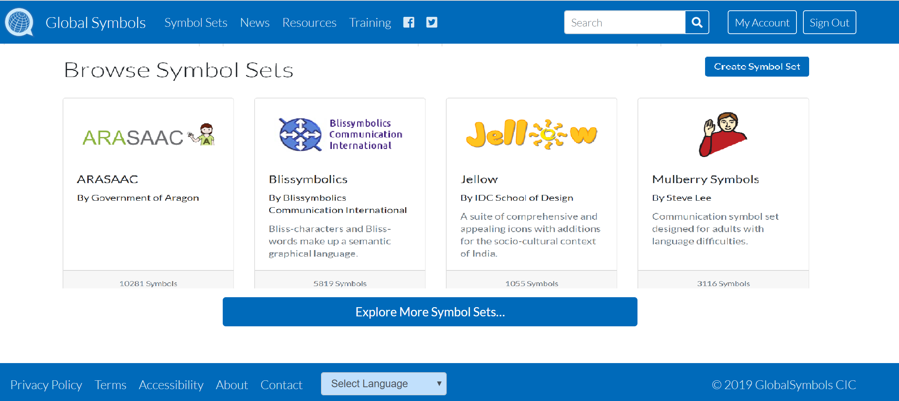
Start creating your first survey by selecting the Sign In or Sign Up in the top menu on the website. (https://globalsymbols.com/)
Use the Language menu in the footer (bottom menu) if you need the website translated.

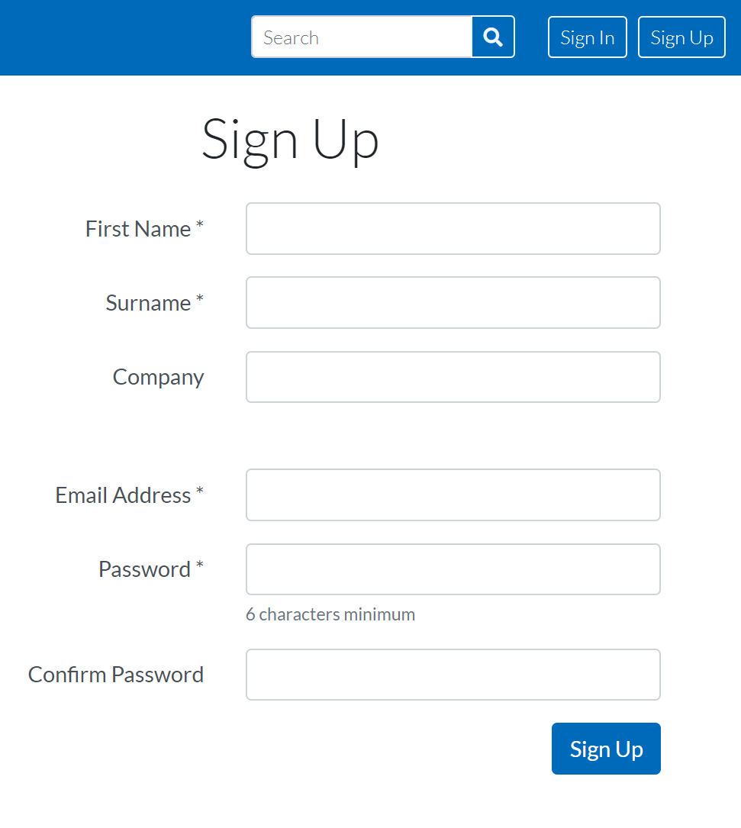
Sign In or Sign Up:
- Select Sign Up from the main menu bar
- Fill in the form and select the Sign Up button
- Please note none of your data is knowingly passed onto other organisations, businesses or individuals.
- If you have already signed up, select Sign In at the top or bottom of the page and you will be asked for your email address and password.
- Select Forgot your password? If you have lost your password or want a new one. You will be sent the reset password instructions by email once you have filled in your email address.

My Account:
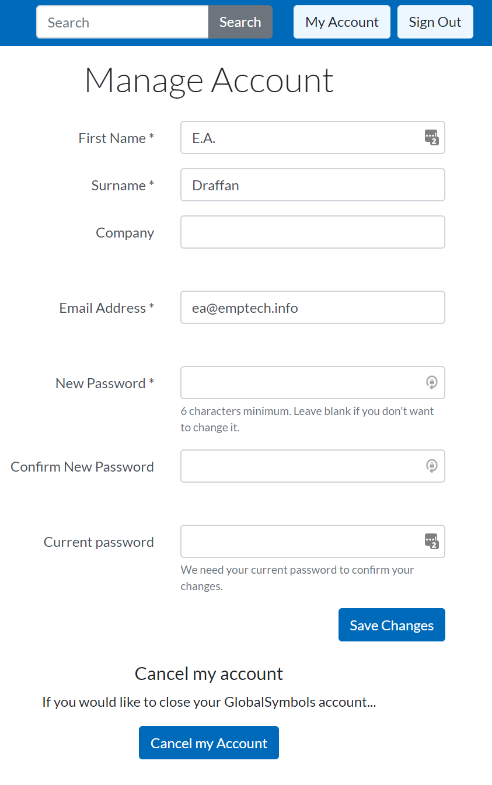
- You can change your account settings at any time by going to My Account at the top of the page.
- Your password can be changed
- You can cancel your account with Global Symbols and all your data will be removed, including your voter surveys unless you request a new owner to take them over.
- Contact Global Symbols via email hello@globalsymbols.com

Because Global Symbols is a repository of symbol sets it is important to start by creating a symbol set in order to make a survey for voting. The name of your symbol set will always bring you back to the survey button!
If at any time you are stuck in the process, because this is all happening in a browser you can always use the back button.
Browser top left hand corner arrow or alt+left arrow

Create a New Symbol Set:
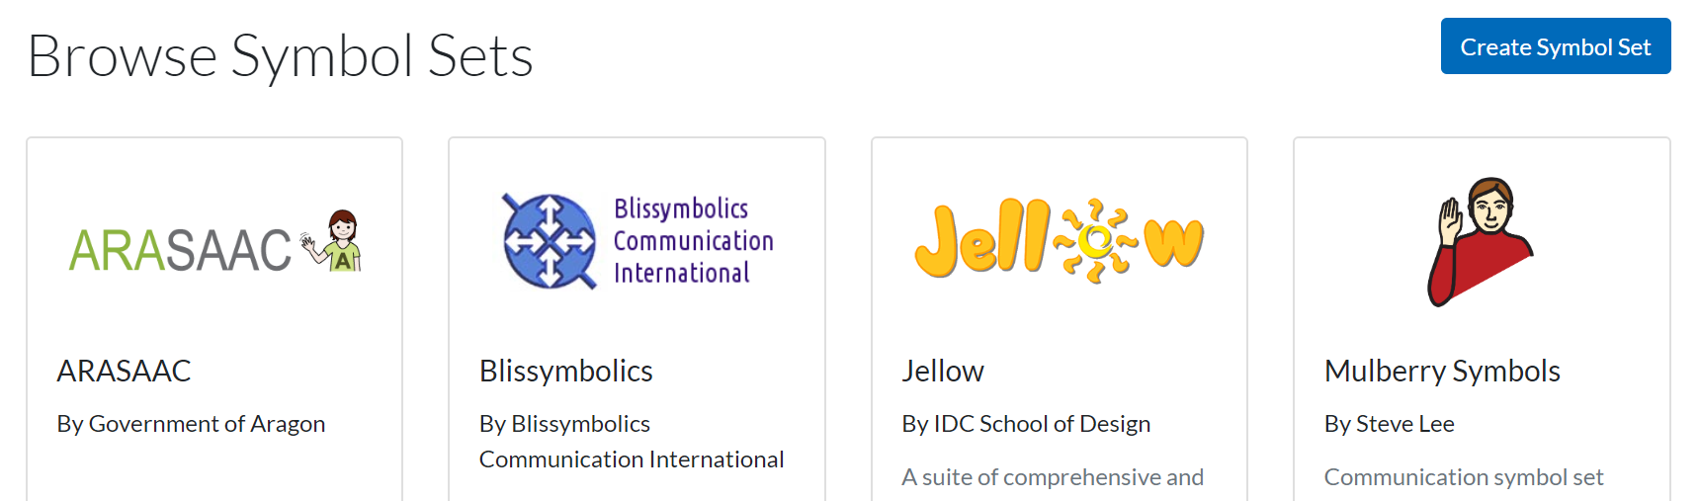
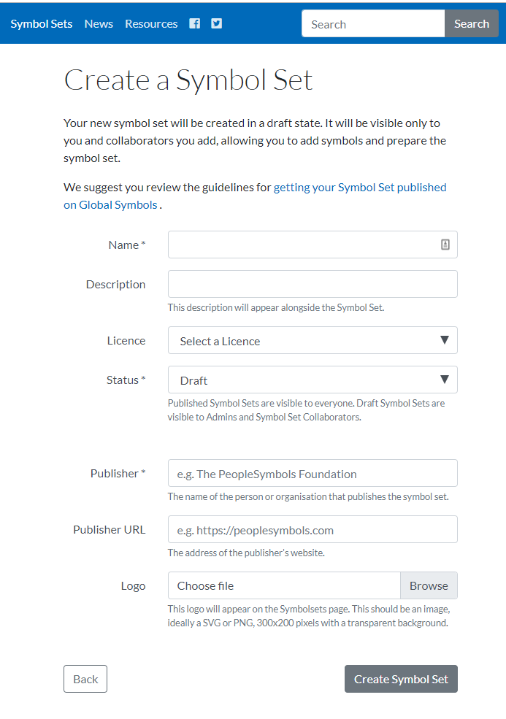
Select Create Symbol Set from the Symbol Sets page.

- You do not have to fill in all the details at this stage other than the Symbol Set name and making sure the publication status remains as Draft.
- You will be able to change the Symbol Set details on the Symbol Set page by selecting the name of your Symbol Set and edit
- Once you have selected Create Symbol Set below the form you can start adding new designed symbols.

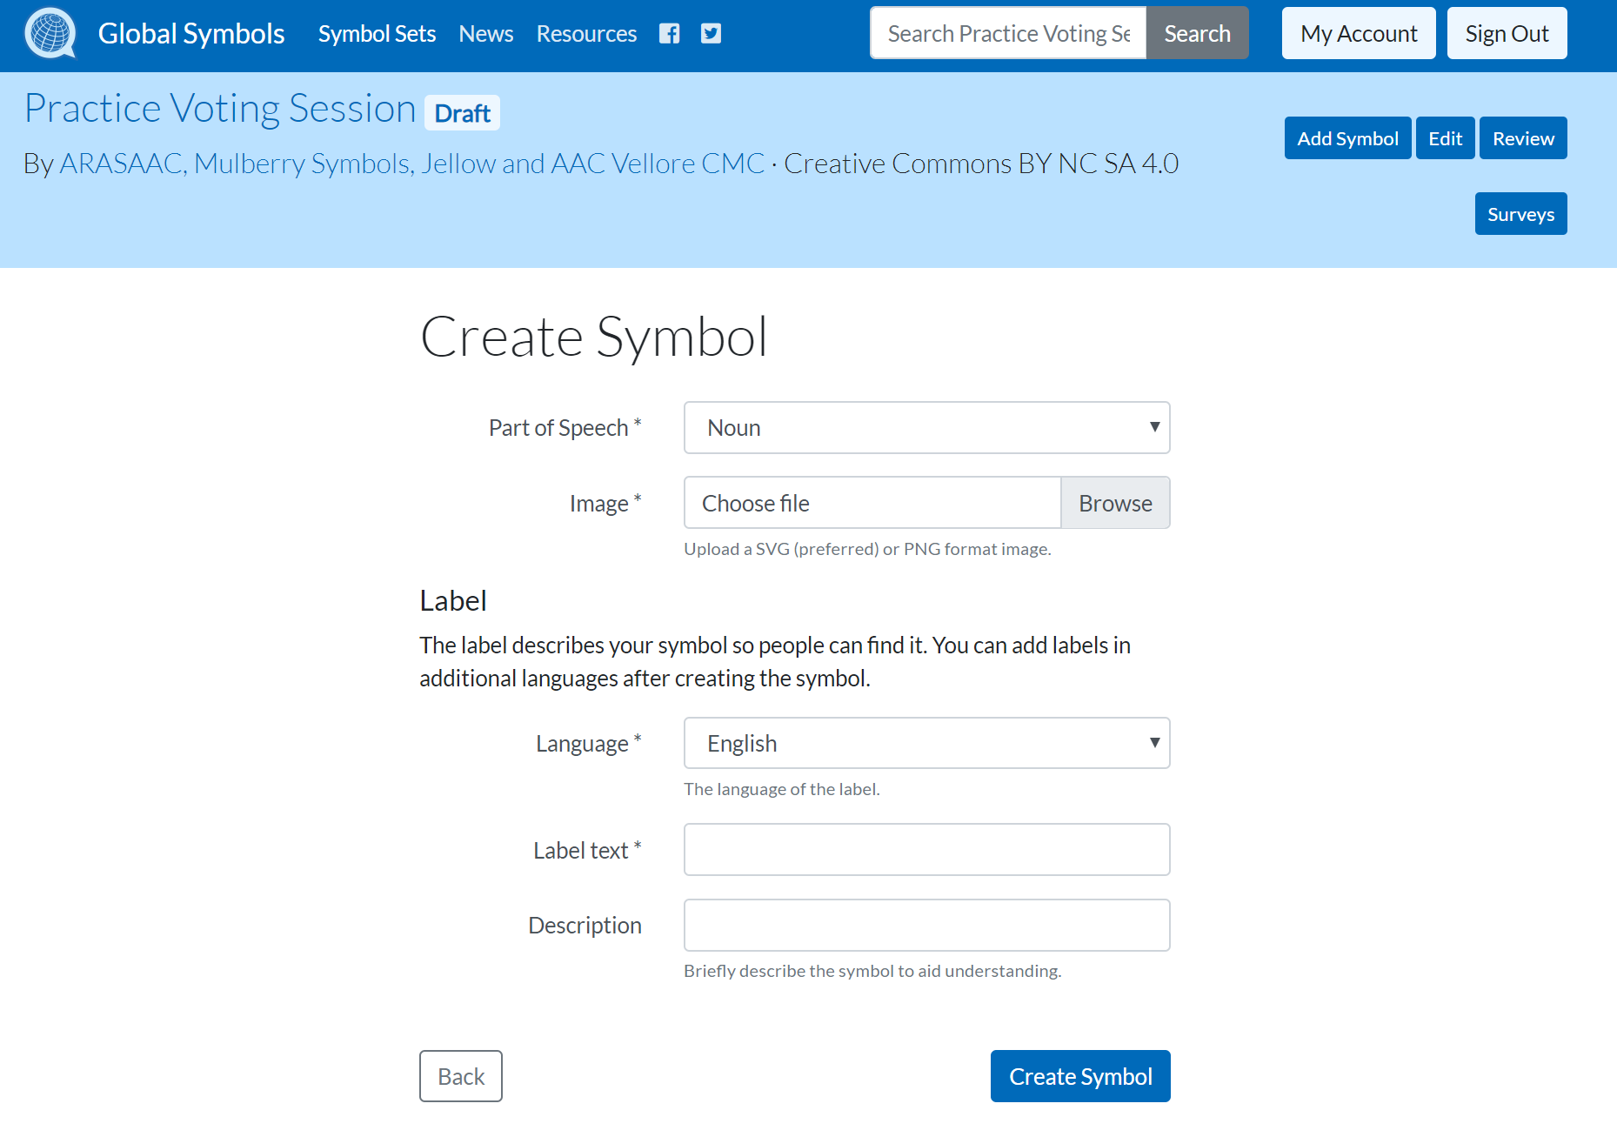
Create a New Symbol:
- Select Add Symbol and you will be able to upload a chosen symbol from your own computer / tablet or online folder. Please use .svg or .png (500 x 500 pixels is advised)
- Once you have uploaded the first symbol and can see it is in the symbol set. You can keep selecting Add Symbol until you have all the new symbols in place.

Adding new Symbols to a Survey:
- To make a survey for voters, Select each symbol individually, check the details, edit if necessary and add a concept or change the language etc. Then Add to Survey
- You can check the symbols you have added to the survey selecting the name of your symbol set, then select the Surveys button to move to the next stage.
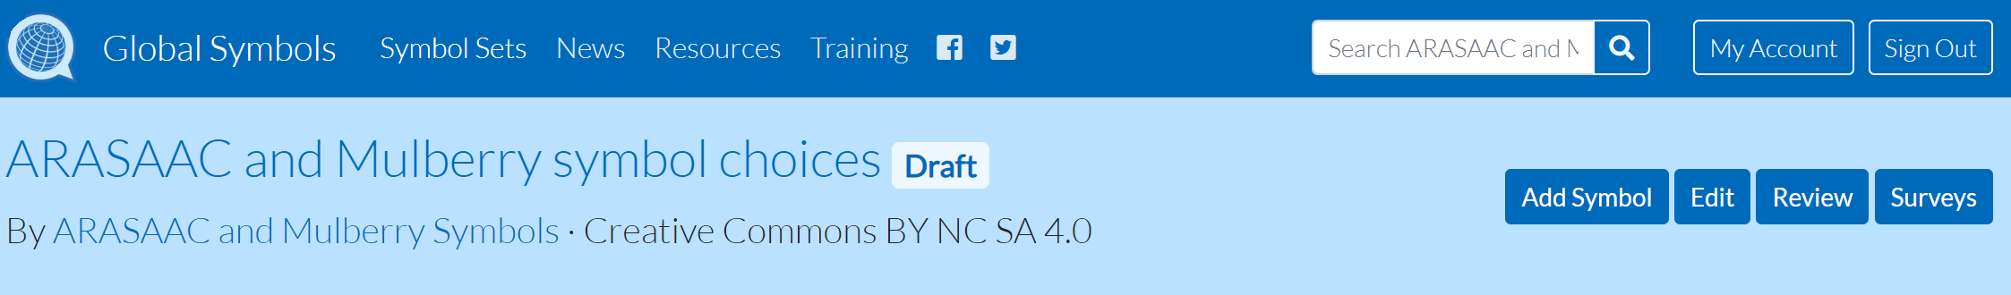

Surveys: Plan
Building a survey for voters involves the need to Plan which symbols to pick for the survey; Collect Feedback from the participants; time to Analyse Results using an Excel sheet in any way you choose and the ability to Archive or Delete surveys.
- If at this stage you have not made a survey, now is the time to Create a Survey and go back to your newly created symbols using the symbol set name to add them for voting.
- You can also search other symbol sets to add more symbols for voting.
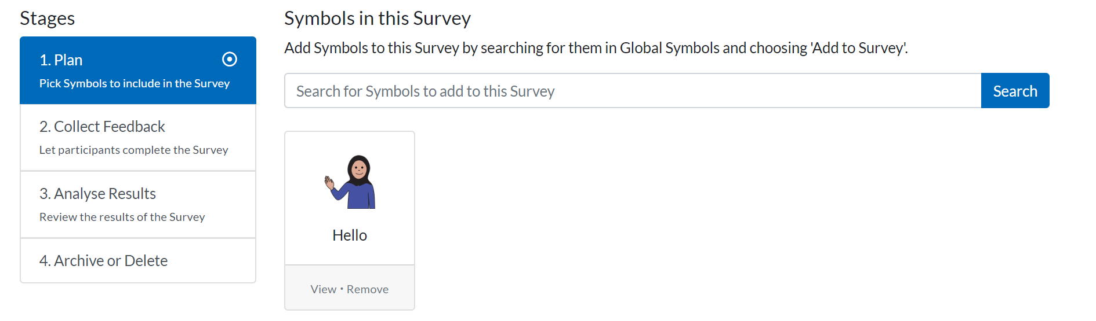
- You will see the search result with a second search box allowing you to change the search criteria if the result was unsatisfactory
- Selecting the symbol view offers more editing possibilities, along with alternative choices of symbols at the bottom of the page. Once Add Symbol has been selected a message will appear offering you the chance to add more symbols and once you have the number of symbols you want in your survey you can move on by selecting Collect feedback

Surveys: Collect Feedback
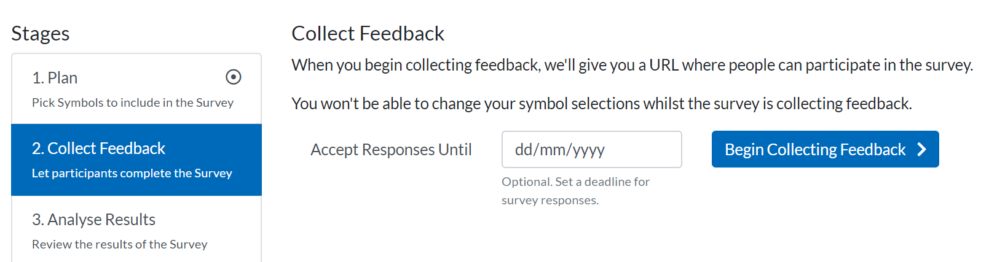
- When collecting feedback you can leave your survey open without an end date but if you are planning several voting sessions it can be helpful to request that everyone completes the survey by a certain date.
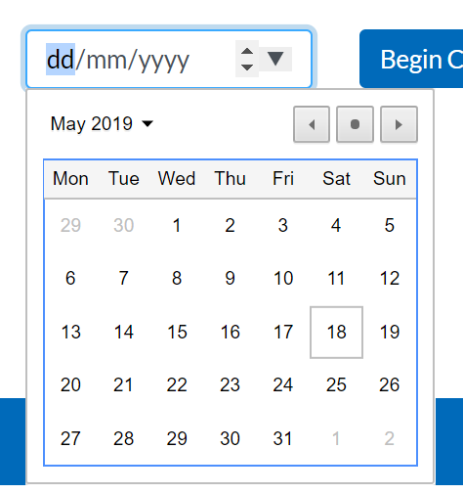
- A calendar will appear when you select the down arrow in the date field. This date can be changed at any time.
- Select Begin Collecting Feedback, you will be give an URL (web address in red) that you can copy and send out to voting participants. There will be no need to Sign up on the Global Symbols website in order to take part.
- You can check your survey by putting the URL into your browser and working your way through the series of symbols you have chosen.
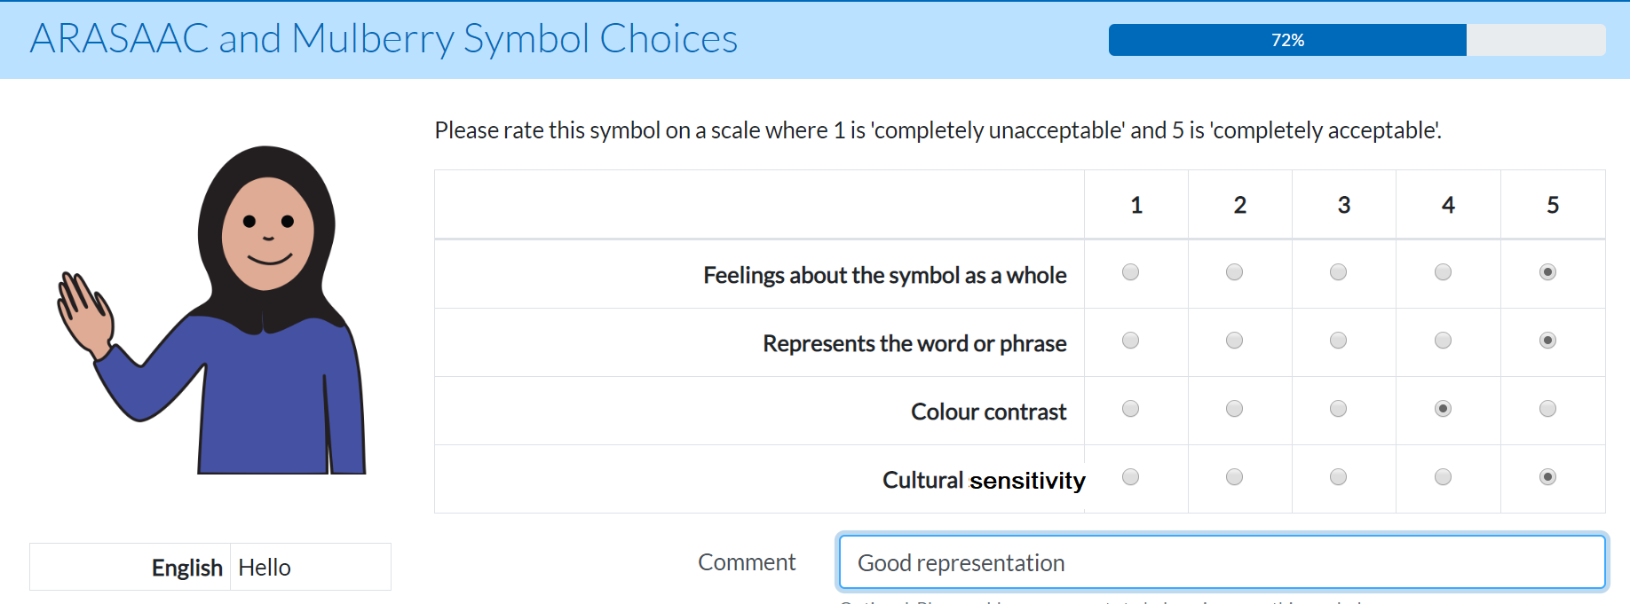
- Continue to the next symbol – you will see a progress bar above the check boxes
- A voter can select Previous question to change their choices and Save Answer to go to the next symbol
- At the end of survey it is still possible to Amend your Answers
- Return to the survey page to Analyse Results

Surveys: Analyse Results
- It is possible to view Individual Responses and all the Symbol Statistics online where it may be considered that any score below 3.5 means that a symbol needs to be re-designed.
- Follow the instructions to Export data to Microsoft Excel for your own Analysis off line. You will have a .csv file with links to the symbols.

Surveys: Archive or Delete
- If you Archive the Survey you have finished you will be able to carry out further analysis at any time. If you Delete the Survey the results will be lost, but not the symbols as these will remain in the draft Symbol Set and can be published or redesigned when required.

