Global Symbols

AAC Symbol Paper based Voting Sessions
These voting sessions can take place with mixed groups including AAC users with an assortment of devices from speech generating devices to E-Tran frames or flash cards plus therapists, teachers, assistants, family members and carers.

Materials Required:
- Video/Stills Camera.
- Consent forms for participants if you are using the results for research purposes or the anonymised data collected will be open to the public.
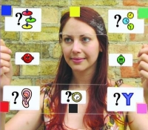
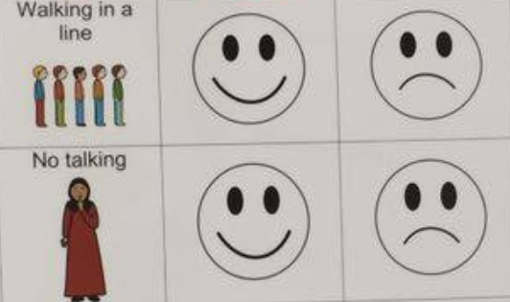
- Select the ways to provide the symbols and voting choices for your survey. PowerPoint slides provided in advance or as a slide show may also be used with voting sheets using the 2-5 scale options for handwritten surveys.
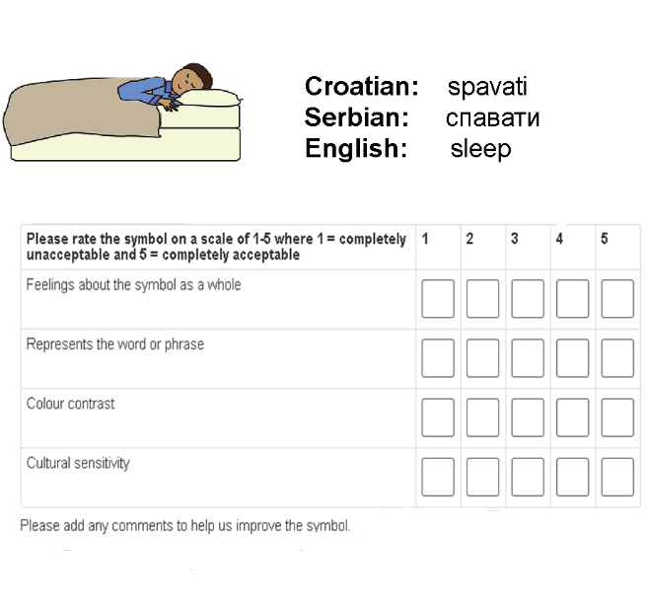
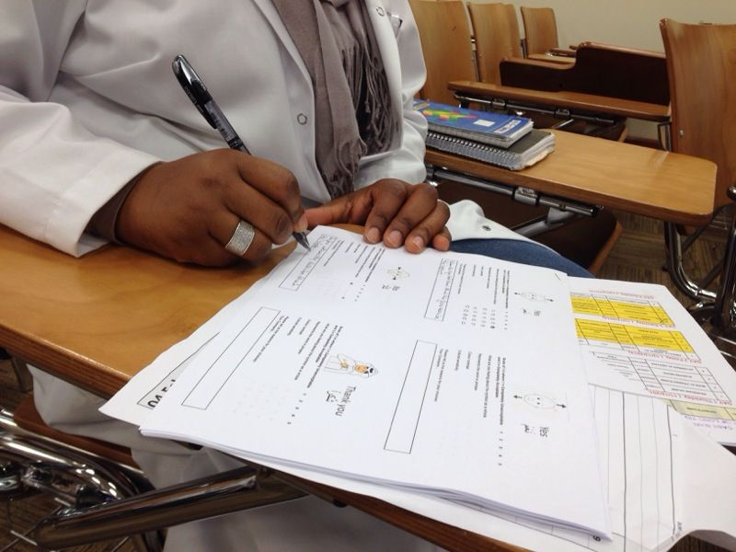
- The results will be manually uploaded to the online voting system with comments.

Set up:
- Explain the project background, purpose of the voting session and introduce the symbol voting interface to all participants.
- Explain consent related issues (i.e. is the family/individual happy for video/audio to be used for recording, research and/or dissemination purposes).
- Sign consent forms.
- Set up camera as appropriate (if participant does not wish to have their face portrayed on film, then position camera over shoulder, so that only the voting screen is clearly visible and user is not recognisable).
- Establish the fact that collaborative discussions are welcomed.

Voting:
- Explain the key features of the symbol voting grid, making sure the reasons for voting in favour or against a particular symbol are clear e.g.
  - feelings about the symbol as a whole (immediate reaction, iconicity, transparency, ease of recognition)
  - represents the word or phrase (referent/concept)
  - colour contrast (outline and colours used for clarity and visually impaired)
  - cultural sensitivity (appropriate and relevant) and
  - general comments not mentioned in the list above, such as size or background etc.
- When talking about the first symbol, state the intended meaning of the symbol to the participants and ask how well this symbol represents the concept, indicated by choosing the voting options on the survey sheets.
- Once a choice is made, confirm understanding with the participants before moving onto the next set of options.
- Allow time for the choices to be noted on the scoring sheet.
- Continue to the next symbol
- Repeat steps until the survey is complete (it may take two or three votes to establish clarity).
- It is important to note where possible relevant discussions between participants about the symbols, as these can help with the symbol criteria in the future.

Upload symbol votes to the online survey system:
- Add new symbols or gather the already developed symbols into a new survey session on the Global Symbols site
- Make sure the names of the participants are registered as having logged in.
- Add their votes and comments to the relevant survey for the appropriate symbols
- Close the survey feedback session and access the appropriate analysis sheet.

