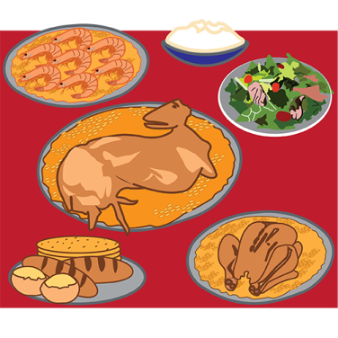  Food | 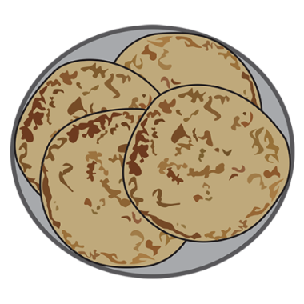  Chapati | 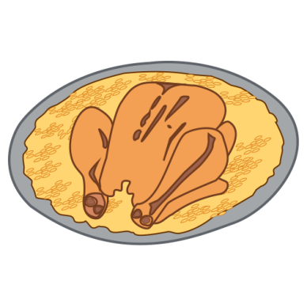  Chicken Machboos | 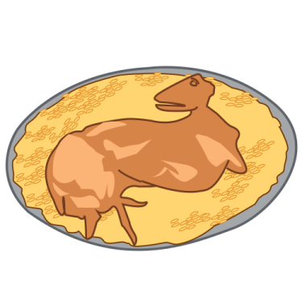  Lamb Machboos
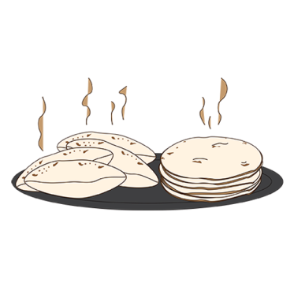  Pita bread | 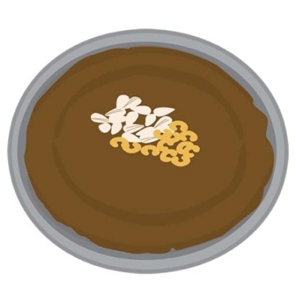  Aseeda | 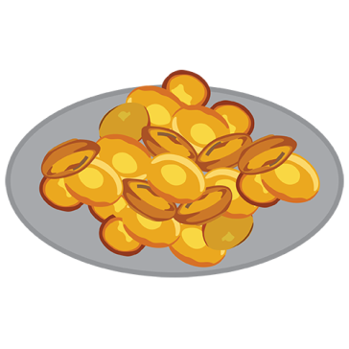  Khanfaroosh |   Dates
Food | Chapati | Chicken Machboos | Lamb Machboos
Pita bread | Aseeda | Khanfaroosh | Dates
Memory - Qatari Foods

