When I am hungry I

When I am thirsty I

When I am tired I

When I am happy I

To call someone I use a

I use a pen to

I like to drive a

I buy things from a

I buy things using

I wash my body in the

I dress myself in

I hang my clothes in the

I like to drink hot

I love my
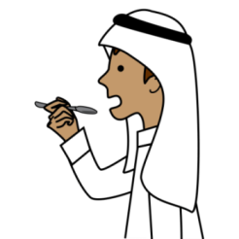  Eat | 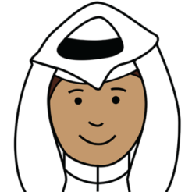Smile | 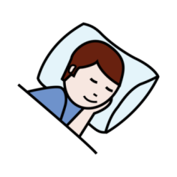  Sleep | 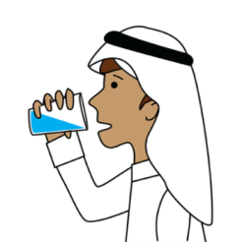  Drink
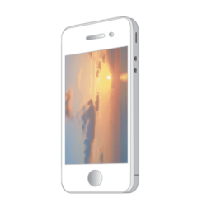  Phone | 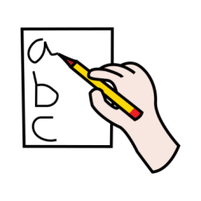  Write | 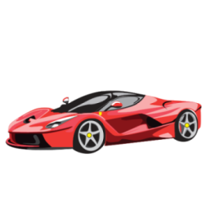  Car | 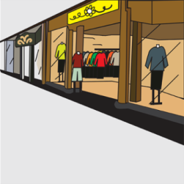  Mall
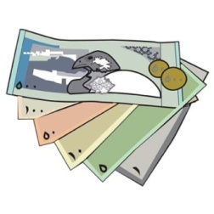  Money | 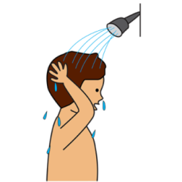  Shower | 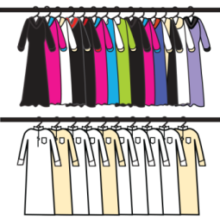  Clothes | 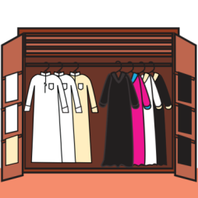Wardrobe
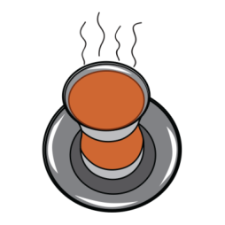  Tea | 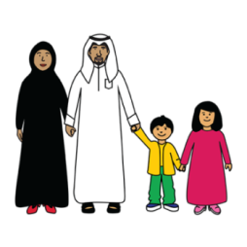  Family

This resource is brought to you by Tawasol. For more information visit www.tawasolsymbols.org.
Some symbols may come from ARASAAC - Pictograms' author: Sergio Palao Origin: ARASAAC (http://catedu.es/arasaac)
Licenses: CC (BY-NC-SA)

