Meet Milo, 3 years old
Milo is a young boy who has just been diagnosed with high-functioning autism. Milo has developed very little functional speech and instead communicates through behaviours including screaming, running and hiding. He had tried a few communication aids prior to his diagnosis and did not get on with devices that used vocabularies sorted in categories. Milo is being supported by a speech and language therapist and an occupational therapist at a Child Development Centre. Next year it is hoped he’ll join a mainstream reception class in a local school.

The Communication Solutions Used
Milo has started developing his AAC language using the Vocabulary Builder that is featured in the Words for Life app. He is also using a paper-based version of LAMP although
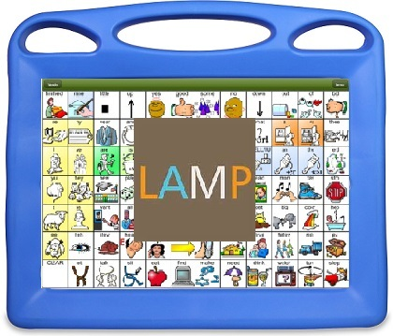
Low-tech Milo uses a paper chart of the top page of LAMP which has been laminated. He gets distracted by the feel of the lamination and doesn’t seem interested, but it is still the best tool in some situations such as when Milo is at the swimming pool.

High-tech. Milo uses the LAMP communication system using the Words for Life app on an iPad in a robust case. He has been using Vocabulary Builder to develop his language from a few symbols until he reaches the full level of available words. On the first stage only the first page of symbols are available. Multi-page navigation comes in future stages known as transition and ‘full’. LAMP Words for Life has speech output so it can easily be understood by everyone, including Milo’s peers.

[IMAGE: https://www.acciinc.com/dedicated-acci-choice-lamp-words-for-life-medicare-model/]

Implementation
The teacher and teaching assistant are both expected to model the use of the device to help develop Milo’s confidence and skills. The speech and language therapist will provide explicit instruction and monitor her improvements in four key competency development areas. It is felt that Milo will learn the LAMP system quickly as it relies on learning motor planning but as his existing experience of communication is so limited he needs to start with some simple implementation ideas.

 | Current Goals
Strategic | Actively engages communication partner during the interaction to monitor their attention and understanding
Linguistic | Consistently uses single messages during familiar interactions
Operational | Transports AAC system in routine or familiar activity with reminders as needed
Social | Participates back and forth (turn taking) for more than two turns in social situations and activities

Goals sourced from Tobii Dynavox Pathways.

