Meet Petra aged 6.

Petra has Autism Spectrum Condition and attends a language unit within a mainstream school. She has support 15 hours of 1:1 teaching assistant support throughout his school week. The local Speech and Language Therapist reviews Petra’s communication and behaviour supports as required following requests from the teaching staff.

Petra is ambulant and enjoys running to calm herself down. She requires encouragement to remain seated on longer tasks.

The communication solution used

Petra communicates using facial expression, gesture, body language and vocalisations.

Low tech/Paper Based AAC;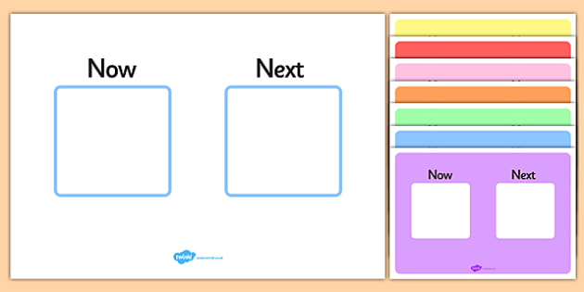

Now/Next: Petra benefits from communication partners using a Now / Next board. The ability for Petra to see what is currently expected of her and what will happen next can calm her down. This can also encourage her to focus on the task currently being completed. Often a timer will be used alongside the Now/Next board to support her. This website is free.
IMAGE Now/Next Board: https://www.twinkl.co.uk/resource/t-s-111-now-next-visual-aid
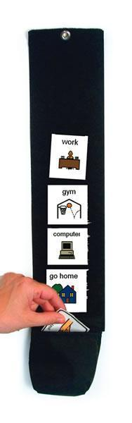
Visual Schedule: She also benefits from using a visual schedule for the school timetable and to follow daily routines e.g. morning routine, travelling to school. Using the visual schedule will

IMAGE Visual Schedule: https://goboardmaker.com/collections/visual-schedules/products/picture-schedule-with-pocket-30-vertical

Core Boards & Activity Boards: Petra currently has access to a core board and some activity based boards for motivating activities. The core boards enable Petra access to the most often used language which can be generalised to be used in a variety of situations e.e.g. ‘More’ apple or playing on swings. It also provides a mixture of language functions including questioning, commenting and requesting. The activity charts enable the individual to have access to appropriate core words but also fringe words that are related to the activity such as playdoh, bubbles. This means that there is no incorrect selection for controlling the activity. Good communication partner skills are imperative to the success of these boards such as aided language input including modelling and sabotage within motivating activities. If the communication partner models (uses the board to state their verbal message) then Petra will over time see this and learn the symbol based communication boards. Both of these resources are free from Core Project or Activity based charts.
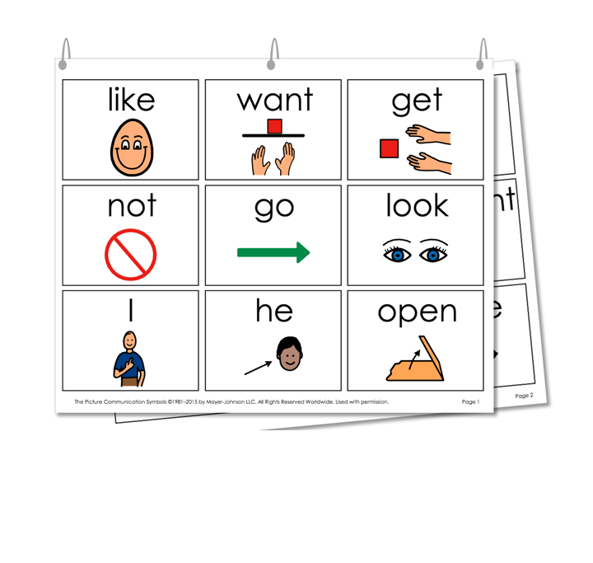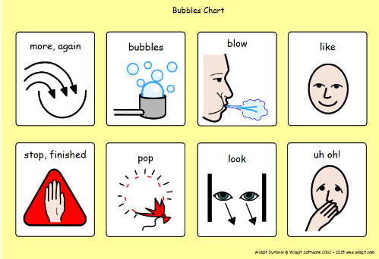
IMAGE Core:http://www.project-core.com/9-location/
IMAGE Activity: https://acecentre.org.uk/resources/bubbles/

High tech AAC; It is not appropriate for Petra to use high tech AAC at this moment in time. It is important for her to understand the purpose of the communication system, which she will be able to do from the paper based system. The systems in place will also help develop her cause and effect understanding.

Implementation

It is imperative to the success of the communication tools that all communication partners model the communication systems. The local Speech and Language Therapist will provide explicit instruction and monitor her improvements in four key competency development areas:

 | Current Goals
Strategic | Obtains the communication partner’s attention before communicating a message
Linguistic | Uses single messages during an activity to request more of a preferred activity or produce the repeated line in a story/song with partner reminders
Operational | Positions AAC system for use with reminders as needed
Social | Communicates messages such as more, all done and help, etc., using signs, vocalisations, and/or AAC with reminders rather than using challenging behaviours

Goals sourced from Tobii Dynavox Pathways.

