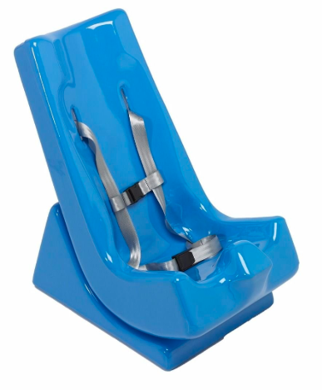
Meet Fiona, 2
Fiona is a young girl with global developmental delay. She has significant learning and physical difficulties, but is usually happy and alert to her surroundings. Fiona attends an early intervention programme in a child development centre for one day a week where she receives occupational therapy, speech and language therapy and physiotherapy. She is not able to walk independently, but is pushed in a pushchair. When in the Child Development Centre she sits in a Tumbleform Floor Sitter.

[IMAGE https://www.amazon.com/TumbleForms-Tumble-Forms-2-H-Strap/dp/B07GP8PS57]

The Communication Solutions Use
Fiona communicates using facial expressions and crying. She is developing communication skills from a pre-intentional stage, meaning that she is learning the core skills required for successful communication such as joint attention, turn-taking.

Low-tech Fiona has a laminated sheet with ‘more’ and ‘stop’ symbols and she is encouraged to use these when engaging in activities in the classroom.
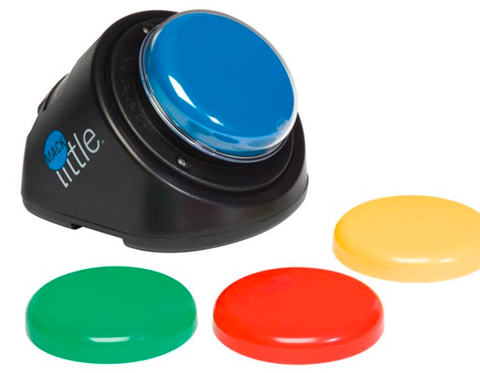
Mid-tech Fiona uses a LITTLEmack switch in a variety of activities to develop a fundamental understanding of intentional communication. Activities include stop/go races, as a ‘more’ button for dancing, and as a repeated line in her favourite story books.

[IMAGE http://www.inclusive.co.uk/ablenet-littlemack-p2041]

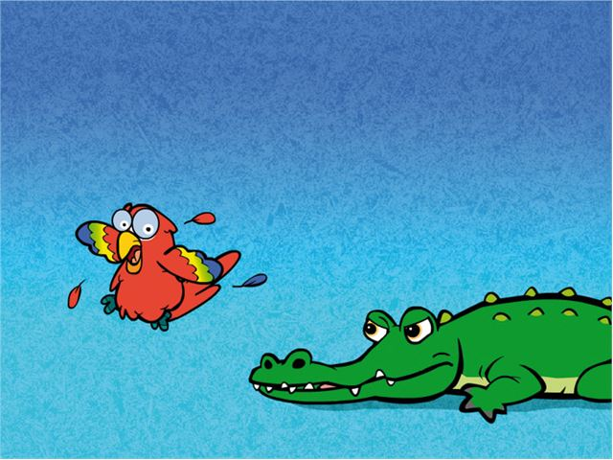
High-tech. Fiona is using switches to develop her foundation communication skills. Although not a communication aid, the switches provide activities that promote turn-taking and joint attention

[IMAGE http://www.inclusive.co.uk/switch-skills-for-two-set-1-p2366]

Implementation
The teacher and teaching assistant are both expected to model the use of the device to help develop Fiona’s confidence and skills. Even better, some of his peers in the classroom have been learning to model, too! This really helps motivate Fiona to use it as a communication aid. The speech and language therapist provides explicit instructions and monitors improvements in four key competency development areas:

 | Current Goals
Strategic | Understanding her communication (e.g. use of vocalisations, pointing, facial expressions, paper-based chart, LITTLEMack etc.)
Linguistic | Uses single messages during an activity to request more of a preferred activity or to produce the repeated line in a story/song with partner reminders.
Operational | Attends to the AAC system looking at it, quieting to listen to it, and/or moving towards it.
Social | Pays attention to communication partner periodically during interactions with a glance, nod, eye contact, touch, or moving near (joint attention)

Goals sourced from Tobii Dynavox Pathways.

