Meet Frederick, 4 years old
Frederick is a young boy with Down’s Syndrome. He is in a reception class in a small country school for children of all abilities. Frederick has his own class assistant who helps him keep on track with his tasks and supports him with his learning.

Frederick has great non-verbal communication skills, such as gaining attention, using gestures and taking conversational turns. However, his difficulties planning his speech and using correct grammar. He also has some difficulty pronouncing words sounds. Both these factors can make it difficult for Frederick to be understood, and he can get very upset about this. Sometimes he can throw his device on the floor rather than try to repair the conversation..

Frederick has some dexterity issues but can hold a big pen in his palm for colouring and is learning to draw shapes. Frederick has been learning to use the free Arasaac symbol set to support his communication.

The Communication Solutions Used
Frederick communicates using his speech and gestures. He uses these with his peers and staff in the classroom and at home. In school he also uses the following aids, although these have not yet been adopted at home:

Low-tech The core and fringe book is a series of laminated pages for individual activities such as drawing, painting, gardening, and telling stories. Frederick uses his book in class with the support of his teacher and teaching assistant. The SLT is also using it with Frederick to help him learn more language through the Arasaac symbols. Frederick has trouble independently navigating between the pages and so he is working on improving this.

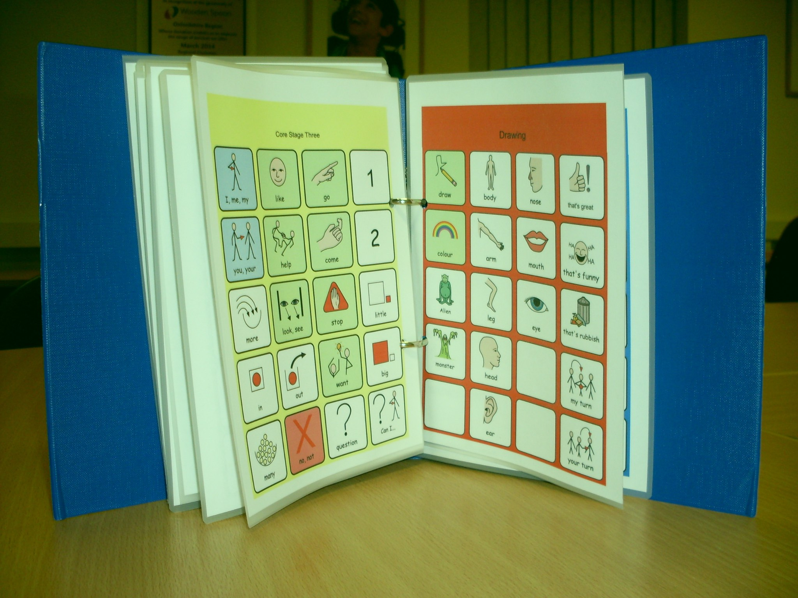
[Image Copyrighted: https://aacbooks.net/books/AdaptingLowTech/]

High-tech. Frederick has an Android Lenovo Tab 7 which was provided by his parents. This allows him to communicate with his peers who do not know symbols, as the device has speech output, The tablet is protected by a BobJGear case to save it from drops and the occasional throw, Frederick is using CoughDrop, and a range of topic boards which are similar to the ones in his book, with 24 symbols per page. Most of the core vocabulary being is on the first page so Frederick has to navigate between pages to construct phrases and sentences.

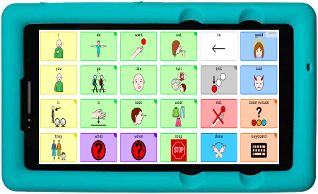

Implementation
The teacher and teaching assistant are both expected to model the use of the device to help develop Frederick’s confidence and skills. Even better, some of his peers in the classroom have been learning to model, too! This really helps motivate Frederick to use it as a communication aid. The speech and language therapist provides explicit instruction and monitors improvements in four key competency development areas:

 | Current Goals
Strategic | Recognises the need to repair a message when intended message is misunderstood, ignored or system did not activate/speak
Linguistic | Uses creative 2+ word sentences during daily activities (e.g. Dog go in, That man fall)
Operational | Navigates to logical page/message/vocabulary during familiar or routine activities
Social | Communicates messages such as more, all done, and help, etc.using gestures, vocalisations and/or AAC rather than using challenging behaviours.

Goals sourced from Tobii Dynavox Pathways.

