Meet Yola, 6 years old
Yola attends a large school for children with special educational needs. She is in a small class with other pupils with physical disabilities. Yola is supported by a teacher and a shared classroom teaching assistant. She sees her speech and language therapist every week.
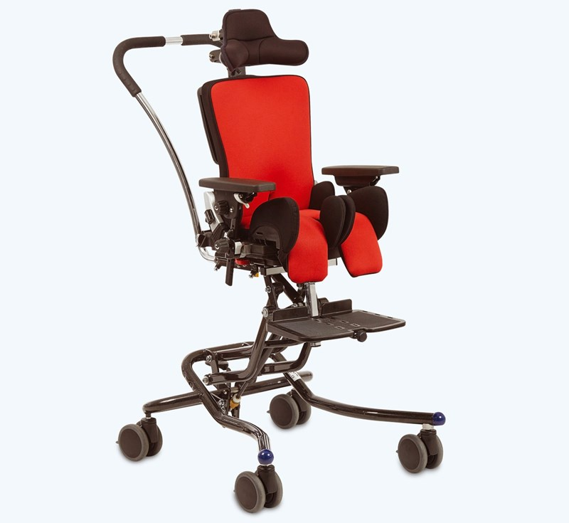
Yola has cerebral palsy which affects her arms and legs. It also affects the clarity of her voice. Her speech can be understood by those who know her very well, including her teacher and close family. It is often difficult for other people to
understand everything she says. Yola’s dexterity and movement of both arms are affected to the extent that she cannot use a pencil and is unable to coordinate both arms together. She uses an x:panda seat in school and at home with a high/low base so that she can sit at various table heights and communicate at eye-level with her peers.

[IMAGE: http://www.r82.org/products/seating/xpanda/c-23/c-69/p-239/?sku=55238]

Yola recognises some words by sight but has not yet developed her decoding skills or phonemic awareness. The school mostly uses Pictorial Communication Symbols (PCS) in their classrooms and resources.

The Communication Solutions Used
Yola communicates using some gestures, vocalisations and some a few Makaton signs. She uses these all the time as part of her total communication approach alongside the following aids:

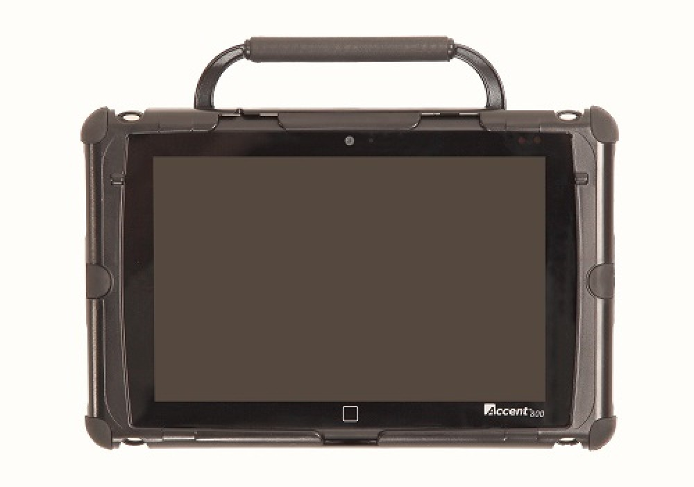
Low-tech Yola is faster at communicating using her colour encoded e-Tran frame than the high-tech device so it’s great for quick and spontaneous conversations with people who are able to use it with her. Her teacher, teaching assistant and speech therapist are all trai
ned to use the e-Tran but none of her classmates can currently use it with her.

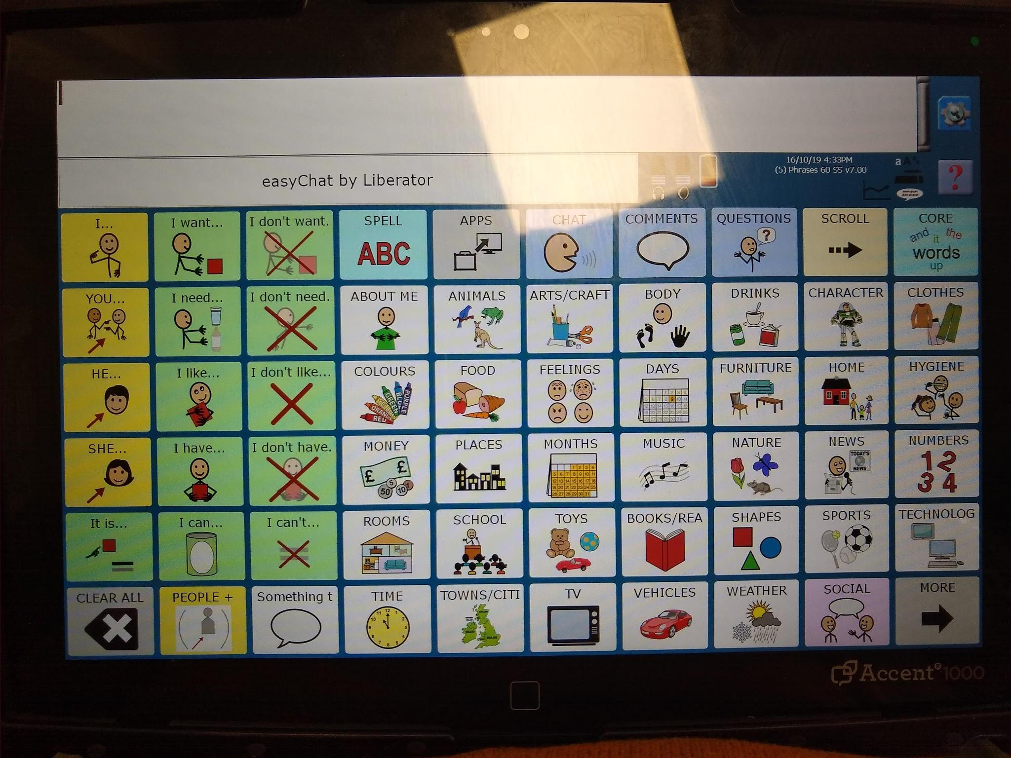
High-tech. The high-tech system produces speech that anyone can understand. Yola prefers to use her hands wherever possible and she is able to make selections on a dynamic screen device if supported by a touch guide. An Accent 800 communication aid is robust, has a loud voice and access to a good range of popular vocabularies.. The easyChat Phrases vocabulary suits her needs well as it provides easy ways to start sentences, quick access to common words and the ability to use a QWERTY keyboard to start developing literacy skills.

[IMAGE: https://www.liberator.co.uk/products/communication-aids/accent-800]

Implementation
The teacher and teaching assistant are both expected to model the use of the device to help develop Yola’s confidence and skills. The speech and language therapist will provide explicit instruction and monitor her improvements in four key competency development areas:

 | Current Goals
Strategic | Obtains the communication partner’s attention before communicating a message
Linguistic | Use common sentence starters (e.g., I want …, I have …, I see … etc.) in structured or routine activities
Operational | Asks for assistance if position of device requires adjustment
Social | Pays attention to communication partner consistently during interactions with regular eye contact or acknowledgement of presence

Goals sourced from Tobii Dynavox Pathways.

